**Introduction to Open-Source Software**

B. Tech Integrated /Computer / Sem IV

**PART A**

(PART A: TO BE REFFERED BY STUDENTS)

**Experiment No.09**

**A.1—Aim:**

To download StarUML software and draw Flow chart using StarUML

**A.2--- Prerequisite:**

* Knowledge of Entity Relationship Model
* Knowledge of Algorithm and Problem solving

**A.3---- Theory:**

StarUML is an open source software modeling tool that supports the UML (Unified Modeling Language) framework for system and software modeling. It is based on UML version 1.4, provides eleven different types of diagram and it accepts UML 2.0 notation. It actively supports the MDA (Model Driven Architecture) approach by supporting the UML profile concept and allowing to generate code for multiple languages

When you start a new project, StarUML proposes which approach you want to use: 4+1 (Krutchen), Rational, UML components (from Cheesman and Daniels book), default or empty. Depending on the approach, profiles and/or frameworks may be included and loaded. If you don't follow a specific approach, the "empty" choice could be used. Although a project can be managed as one file, it may be convenient to divide it into many units and manage them separately if many developers are working on it together.

StarUML makes a clear conceptual distinction between models, views and diagrams. A Model is an element that contains information for a software model. A View is a visual expression of the information contained in a model, and a Diagram is a collection of view elements that represent the user's specific design thoughts.

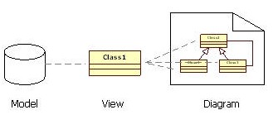

StarUML is build as a modular and open tool. It provides frameworks for extending the functionality of the tool. It is designed to allow access to all functions of the model/meta-model and tool through COM Automation, and it provides extension of menu and option items. Also, users can create their own approaches and frameworks according to their methodologies. The tool can also be integrated with any external tools.

StarUML supports the following diagram types

* Use Case Diagram
* Class Diagram
* Sequence Diagram
* Collaboration Diagram
* Statechart Diagram
* Activity Diagram
* Component Diagram
* Deployment Diagram
* Composite Structure Diagram

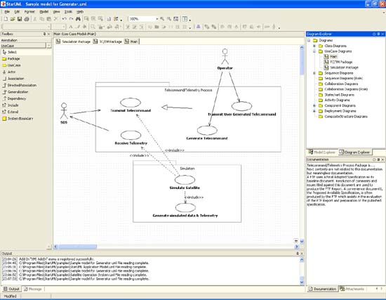

**A.3--- Tasks:**

1. Open Star UML software in windows/MAC operating system
2. Draw flowcharts for following:

a) Draw a flowchart to display the total water bill charges of the month depending upon the number of units consumed by the customer as per the following criteria: • for the first 100 units @ 5 per unit • for next 150 units @ 10 per unit • more than 250 units @ 20 per unit Also add meter charges of 75 per month to calculate the total water bill.

b) Draw a flow chart for finding roots of a quadratic equation

c)Draw flow chart for finding greatest of three numbers.

1. Take screenshots/download the diagrams from StarUML software and paste in in output section
2. Save and close the file and name it as **EXP9_ your Roll no.**

**(PART - B)**

(TO BE COMPLETED BY STUDENTS)

(Students must submit the soft copy as per following segments within two hours of the practical.

The soft copy must be uploaded on the Blackboard or emailed to the concerned lab in charge faculties at the end of the practical in case there is no Black board access available)

|  |  |
| --- | --- |
| Roll.No. : C050 | Name: VIVEAN ARYA |
| Sem/Year : IV | Batch: 2 |
| Date of Experiment : | Date of Submission: |
| Grade -- |  |

# B.1: Procedure of performed experiment

(students are expected to write the reason of the choice of topology and device)

# B.2: Observations and Learning’s:

(Students are expected to comment on the output obtained with clear observations and learning for each task/ sub part assigned)

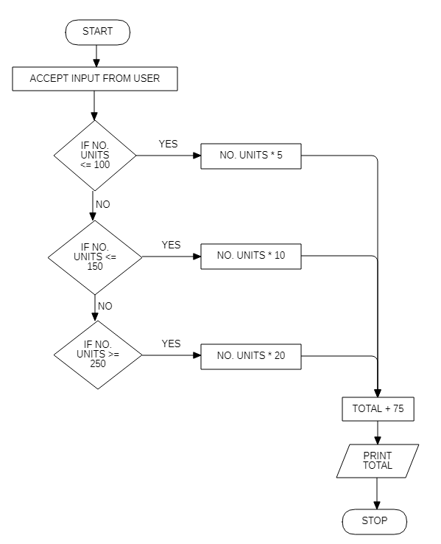

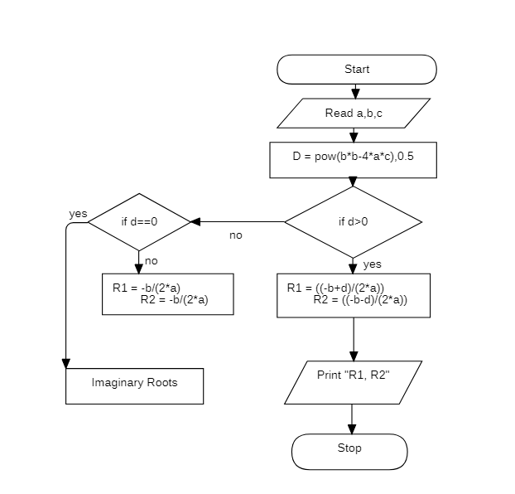

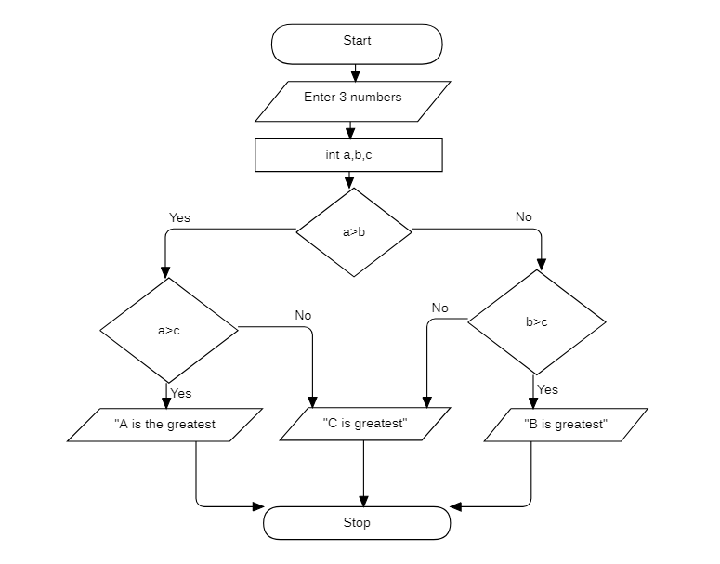

# B.3: Conclusion:

(Students must write the conclusion as per the attainment of individual outcome listed above and learning/observation noted in section B.2)

Made flowchart using star xml